PROFF OF TEST

EXECUTION OF MYE -09

Validation :- This test to validate the look and feel of the calendar

Expected Result: look and feel of the calendar should able to successfully

Screen Shot:

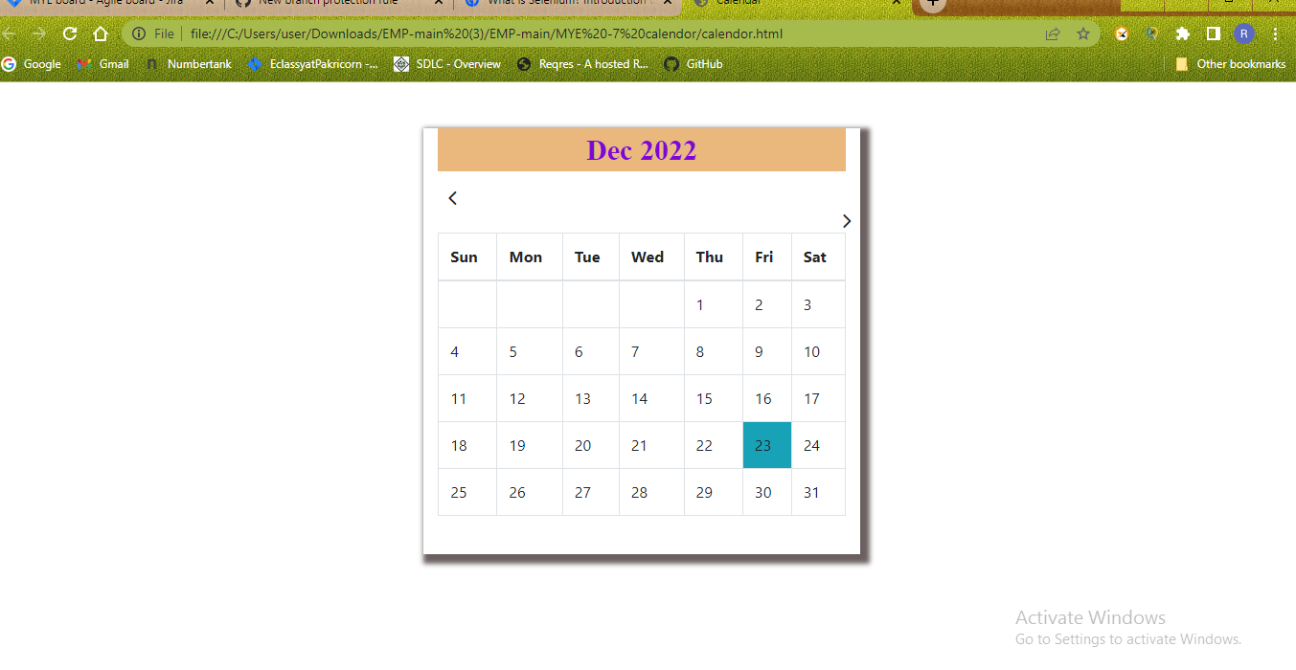Validation -

This test to validate the calendar widget should display the current month ,current date,year

Expected:

The calendar widget should display the current month ,current date,year should displayed

Screen Shot:



Validation:

This test verify to that the user can move to previous and next month’s calendar by choosing the left and right arrow buttons present above the calendar

Expected Result:

User should able to change different months by using arrow buttons

Screen Shot:



Validation:

This test to validate that by default of calendar extends in week format from Sunday to Saturday

Expected Result:

Default of calendar extends in week format from Sunday to Saturday should displayed

Screen Shot:

